**WITHDRAWAL FORM**

(Fill out this form and send it back only if you want to withdraw from the contract within the legal period.)

**Addressee:**

Online store: www.bygreyson.cz

Represented by: Veronika Panakova

Delivery address: Karafiátová 22, 326 00, Plzeň

VAT: CZ07648782

**I hereby declare that I withdraw from the contract for the purchase of these goods:**

Date of receipt of goods:

Order number:

| Product name | Color | Size | Price |
| --- | --- | --- | --- |
|  |  |  |  |
|  |  |  |  |

We will be very happy if you let us know why our piece did not make you so happy, so that we can constantly improve our services (write the number of your reason):

| 1. The cut doesn't fit. | 2. Wrong size. | 3.Unsatisfactory quality. | 4. Different from website. | 5. I don't like it. | 6.Changed my mind. |
| --- | --- | --- | --- | --- | --- |

**Consumer:**

Name and surname:

Address:

Phone:

Email:

Bank account number:

Date ……………………..… 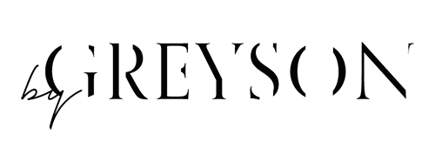Consumer signature: ……………………………………………